**Travel Instructions for ETSI 2016 Faculty**

Before purchasing the airline tickets, please refer to document titled ‘Suggested Itinerary for ETSI 2016 Faculty’ on ETSI website, which shows important dates for travel.

**Faculty Teaching at Sera Monastery:**

* **International Airfare**: Purchase a round-trip airfare to Bangalore. (See Purchasing Airline Tickets below)
* **Hotel**: The ETSI will arrange rooms for faculty members teaching at Sera Monastery at Presidency Hotel, which is located near Bengaluru International Airport (about 15–20 mins ride). The faculty will spend the night of their arrival, and a night or two prior to their departure to the United States at this hotel. A representative from the hotel will meet the faculty at the airport and take him/her to the hotel. The ETSI will reserve the hotel rooms. The Breakfast is complimentary.

Hotel Presidency website <http://www.hotelpresidencyblr.com>

Our contact person at the hotel: Mr. Srinivas

Email: [enquiry@hotelpresidencyblr.com](mailto:enquiry@hotelpresidencyblr.com)

Office number: 9620222807 (to call from the US, dial 011, then India’s country code 91)

Personal number: 8095020349 (This number is only for emergency use.)

* **Car to Sera:** On-site ETSI science coordinators from Sera Monastery will meet the faculty members at the Presidency Hotel the next morning and ride with the faculty to the monastery (which is about 4-5 hours). The faculty should plan on leaving the hotel around 10:30 am.

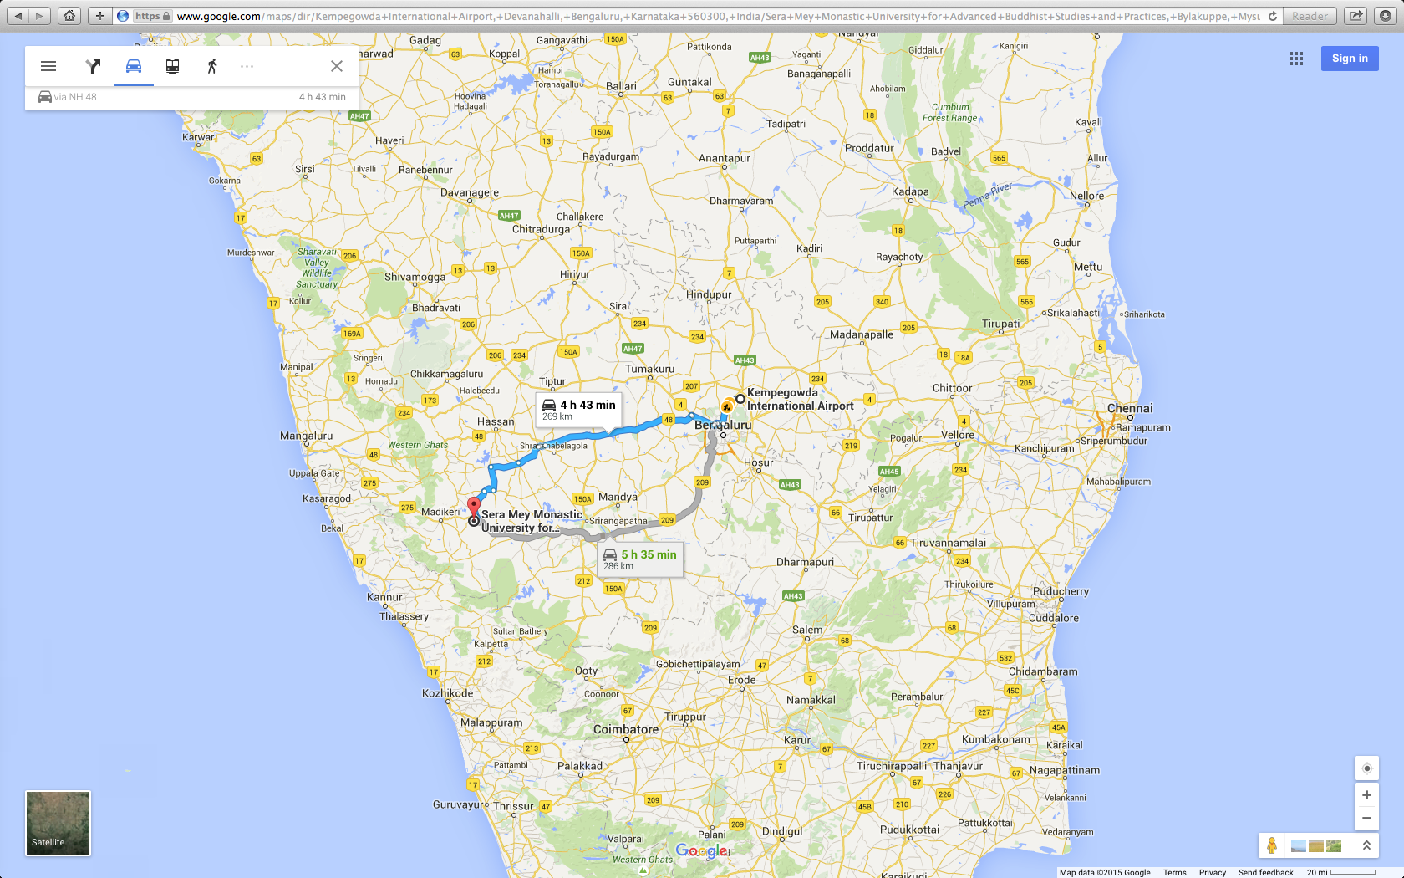

* **Return Travel**: Either the on-site science coordinators or the local ETSI program staff will accompany the faculty members on the ride back to Presidency Hotel in Bangalore. The hotel will be informed of the flight schedules and it will arrange for drop-off service to the airport.

**Faculty Teaching at Gaden or Drepung Monasteries:**

* **International Airfare**: Purchase a round-trip airfare to Mumbai. (See Purchasing Airline Tickets below)
* **Domestic India Airfare**: The ETSI administration will purchase a round-trip Mumbai-Belgaum air tickets for all the faculty going to Gaden or Drepung. If spouses/partners are traveling, the faculty must inform us in advance. We will send the flight itineraries to the faculty by April 2016 – a month before the ETSI Summer Program begins.
* **Hotel**: The ETSI staff will reserve rooms for faculty members teaching at Drepung or Gaden at IBIS Hotel, which is located near Mumbai International Airport (about 15-20 mins ride). The faculty members will spend the night of their arrival, and a night or two prior to their departure to the United States at this hotel. A representative from the hotel will meet the faculty at the airport and take him/her to the hotel. The breakfast is complementary.

Hotel IBIS website: [http://www.ibis.com/gb/hotel-6367-ibis-mumbai-airport/index.shtml#](http://www.ibis.com/gb/hotel-6367-ibis-mumbai-airport/index.shtml)

Our contact person at the hotel: Mr. Zuhayr Kazi

Email: [H6367-SL5@accor.com](mailto:H6367-SL5@accor.com)

Office number: 2267167777 (to call from the US, dial 011, then India’s country code 91)

Personal number: TBA (This number is only for emergency use.)

* **Mumbai Domestic Airport**: The hotel will provide transportation to the Domestic Terminal of Mumbai Airport for the Mumbai-Belgaum flight. Flight tickets will be sent to the faculty in April 2016.
* **Car to Monasteries:** On-site ETSI science coordinators from Drepung and Gaden Monasteries will pick up the faculty at the Belgaum airport and accompany the faculty to their respective monasteries (about 2-3 hour drive).

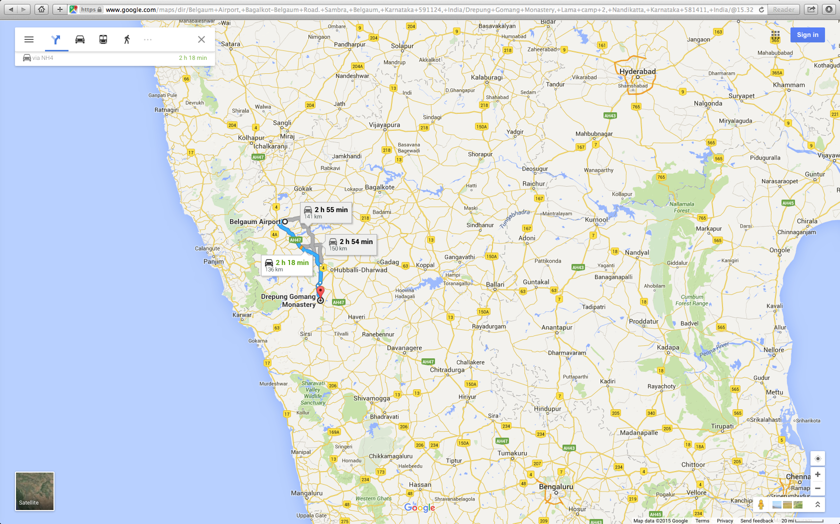

* **Return Travel**: Either the on-site science coordinators or the local ETSI program staff will accompany the faculty members to go to the Belgaum airport. From there the faculty flies to Mumbai where he/she can spend a night or two at IBIS Hotel before catching flight back to the US. The hotel will drop off the faculty to the Mumbai International Airport.

**Other Plans:** Of course, the faculty members are certainly free to make any plans for personal excursions at his/her personal expense before or after the teaching days at the monastery. Please discuss your plans with ETSI Program Coordinators. Since ETSI is confirming hotel reservations, the faculty members are expected to arrive at the IBIS Hotel on the dates shown on the ‘Suggested Itinerary for ETSI 2016 Faculty’.

**Purchasing Airline Tickets:**

*Emory faculty/graduate students* are required to use one of the approved Travel Agencies (Tbiz, BCD, or Maupin). The links to the websites of these agencies are present on the Emory Finance website. For on-line purchases, the ETSI accounting smartkey (0000047845) can be used or the faculty can charge their Emory Corporate Card. For any assistance kindly contact BCD Travel (ask either for Bonnie Ferguson or Susan Austin as they are familiar with ETSI program). BCD will be able to charge your flight ticket directly to our Emory account.

Follow this link: <https://www.finance.emory.edu/home/travel/air_travel/index.html>

***Non-Emory faculty*** should contact BCD Travel (ask to speak to either Bonnie Ferguson or Susan Austin). They can be reached at this number: 1-404-727-3000 ext. 2. They have been provided with all the ETSI faculty names, so they can assist you with travel arrangements and will charge the airfare to our Emory account.

Note: Only ETSI faculty expenses can be charged to the ETSI account or corporate card. Guests must make payment using their personal credit cards.

**As soon as you have made your airline arrangements, send a copy of your ticket to tdolka2@emory.edu.**

*(If you have purchased a ticket for your spouse/partner, please send a copy of his/her ticket as well.)*

For your return plans, you may choose to stay one night and spend the next day sightseeing before returning to the hotel, prior to heading to the airport around midnight for the flight back to the USA. Or you may prefer to schedule your international return flight for the same evening you arrive back in either Bangalore or Mumbai. See the ‘Suggested itineraries for ETSI 2016 Faculty’.

**Expenses Paid by the ETSI Program:** The ETSI program will pay for international coach/economy airfares, for one hotel night upon arrival and up to two hotel nights prior to departure from India, depending on your flight schedule. The ETSI will reimburse faculty for reasonable expenses for immunization required for this travel. It will also provide a total of $255 (per diem) to cover miscellaneous expenses such as tips, meals, or other charges incurred en-route. Your lodging and meals while at the monasteries will be provided.

*Arrangements for car travel to the monasteries and Guest House reservations can only be confirmed by the local ETSI Science Coordinators once they receive the faculty travel plans from us.*

**Questions/Comments/Suggestions:** For assistance in finalizing your plans, please contact:

Jim Wynn at [jrwynn@emory.edu](mailto:jrwynn@emory.edu); phone 404-831-4800

Or Tsetan Dolkar at [tdolka2@emory.edu](mailto:tdolka2@emory.edu); phone 404-727-1163